DIGITAL SIGNAL PROCESSING
19MAT211
PROJECT REPORT

Submitted by:
R S ABHINAV VIKRAM : BL.EN. U4ECE22044
R V PAVITHRA : BL.EN.U4ECE22045
RAHUL VARMA : BL.EN.U4ECE22046
Rohit Korada : BL.EN.U4ECE22047

4th semester
ECE-A
Group No:11



AMRITA SCHOOL OF ENGINEERING
Bengaluru-560035
MAY-2024

Project Title: Image Upscaling Techniques and Evaluation

AIM:
This project explores various image upscaling techniques and evaluates their performance using both subjective and objective measures.
OBJECTIVE:
Image upscaling is the process of increasing the resolution or size of an image while attempting to preserve its quality and details. It can make images appear sharper and more detailed, and is necessary for viewing images on high-resolution screens, printing larger images, and treating grainy or blurry images.
Upscaling can be done manually, but it's difficult and time-consuming. Traditional methods can leave images larger but blurrier, like a photocopy of a photocopy.
CODE: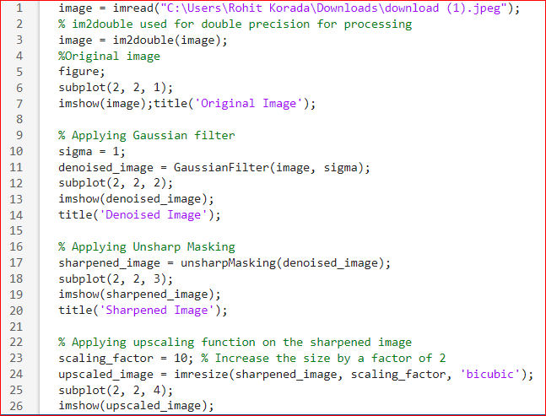
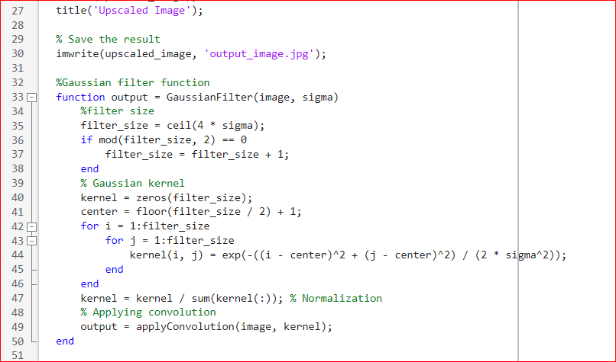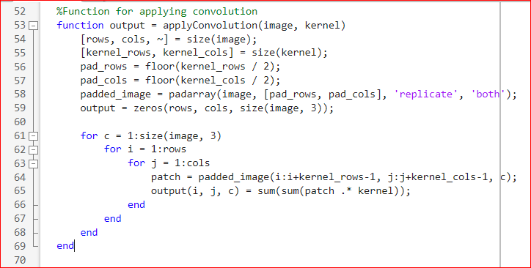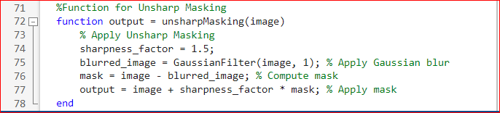

EXPLAINATION OF CODE:
The code has three helper functions:
Gaussian Filter Function (Gaussian Filter): Generates a Gaussian kernel and convolves it with the input image to perform Gaussian smoothing.
Function for Applying Convolution (apply Convolution): Applies convolution between the input image and a specified kernel.
Unsharp Masking Function (unsharp Masking): Enhances image sharpness by subtracting a blurred version of the image from the original and adding it back with a scaling factor.
Upscaling: Specifies a scaling factor (scaling factor) to increase the size of the image by a factor of 10. Uses the imresize function with bicubic interpolation to upscale the sharpened image. Displays the upscaled image in a subplot.
OUTPUT:

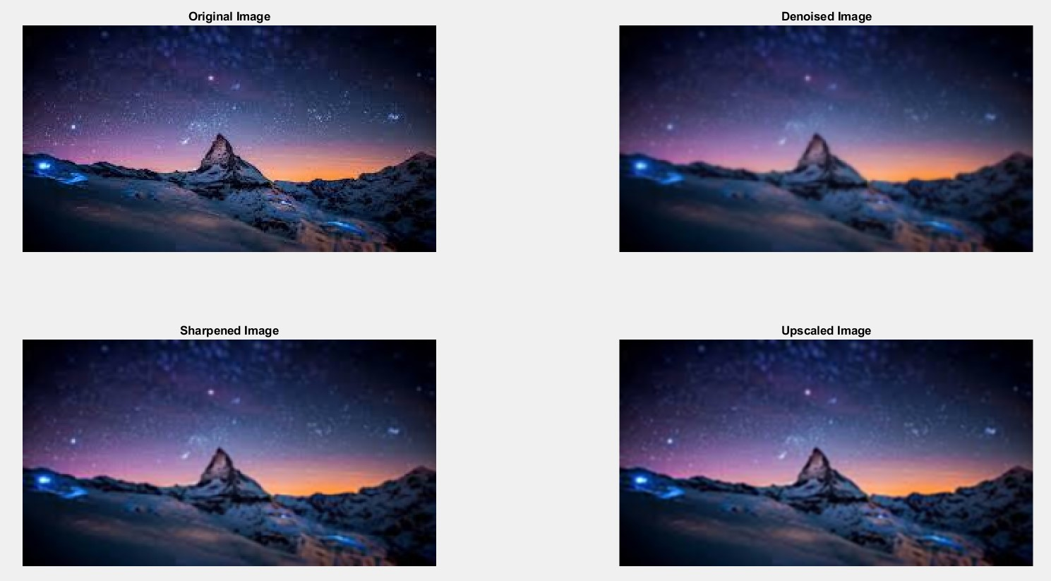
APPLICATIONS:
1.Media and Entertainment
- Gaming: Video game developers employ upscaling techniques to improve the resolution of textures and graphics, resulting in sharper and more detailed visuals.
2.Medical Imaging
- Diagnostic Imaging: In medical imaging, such as MRI (Magnetic Resonance Imaging) and CT (Computed Tomography) scans, upscaling can enhance the resolution of images, aiding in the detection and diagnosis of diseases and abnormalities.
3. Remote Sensing:
- Satellite Imagery: Satellite and aerial imagery often undergo upscaling to increase their resolution for applications such as environmental monitoring, disaster response, urban planning, and agriculture.
4.Photography and Digital Restoration:
- Digital Restoration: Old or degraded photographs can be upscaled to improve their visual quality and restore missing details, preserving historical and cultural artifacts.
- Print Media: Images intended for print publications, such as magazines and posters, often undergo upscaling to achieve higher print resolutions without compromising quality.
Conclusion:
• This project provides a comprehensive comparative analysis of image upscaling techniques, offering insights into their performance and applicability.
• The findings contribute to the understanding of upscaling algorithms and pave the way for future research and development in the field.
• The comparative evaluation framework presented in this report can guide the selection and deployment of upscaling techniques in various applications.

